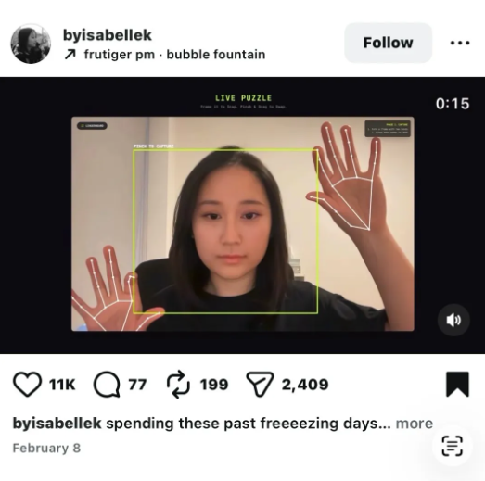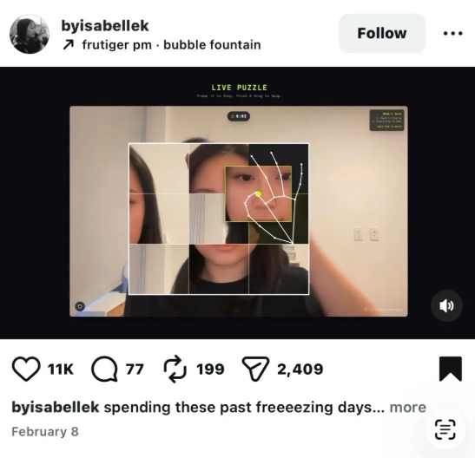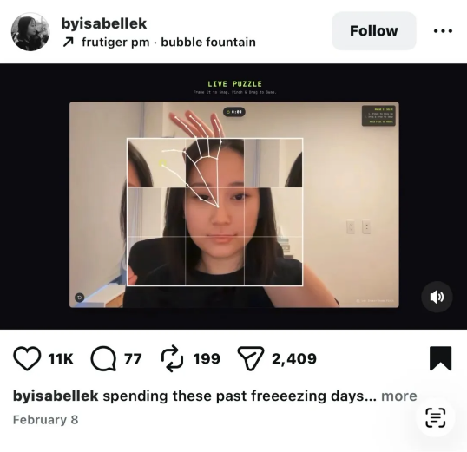
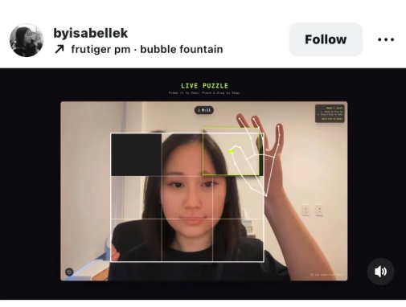
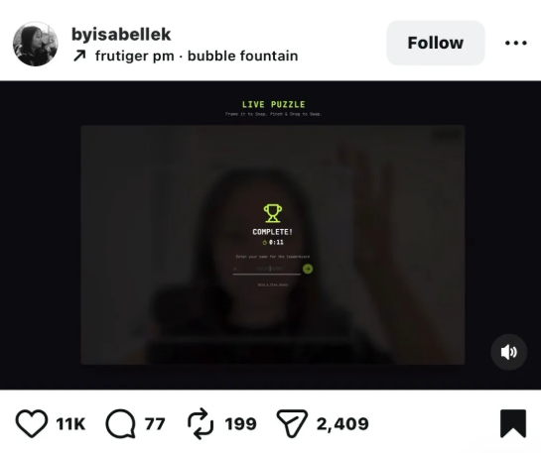

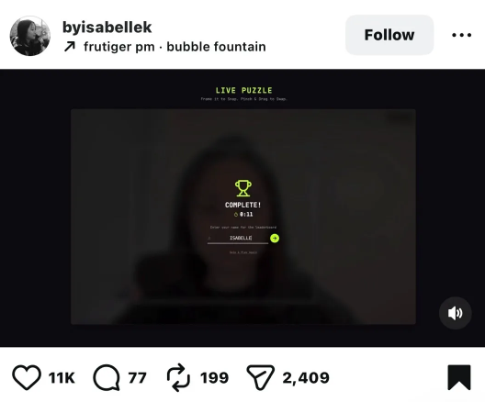

a hand-gesture controlled live puzzle game using your webcam. The flow is:
Phase 1 - Capture: You hold up both hands and form a rectangular frame with them. When you pinch, it "snaps" a photo of whatever's inside that frame (in her case, her own face).
Phase 2 - Solve: That captured photo gets sliced into a scrambled 3x3 sliding puzzle grid. You then use pinch gestures to pick up and drag tiles around to reassemble the image. There's a live timer running.
End screen: Once solved, you get a "COMPLETE!" screen with your time and can enter your name on a leaderboard.

